Watershed Game

- Each students makes a 2-year land-use plan for the Big Creek Watershed selecting from corn, soybeans, hay, and forest on 28 different areas that vary in topography.

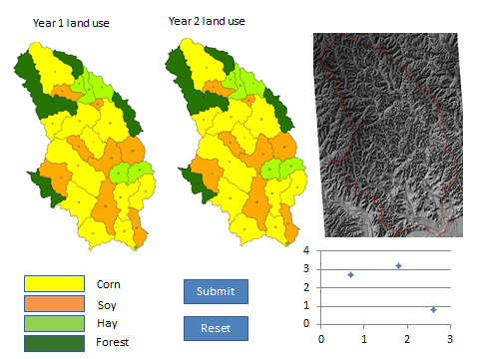

- The computer scores their land use plan drawing from a watershed model called SWAT – Soil and Water Assessment Tool.

- The goal is to maximize crop output (up to $200,000 possible) while also maximizing ecosystem services on a 0-1 scale for a maximum possible of 4 points.
a. soil retention
b. water quality
c. reduced flooding
d. carbon retention

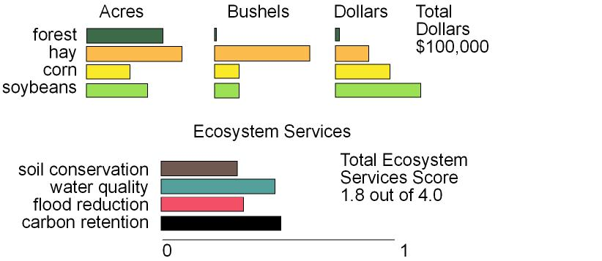

- Results are placed on a graph in comparison to other student’s maps.

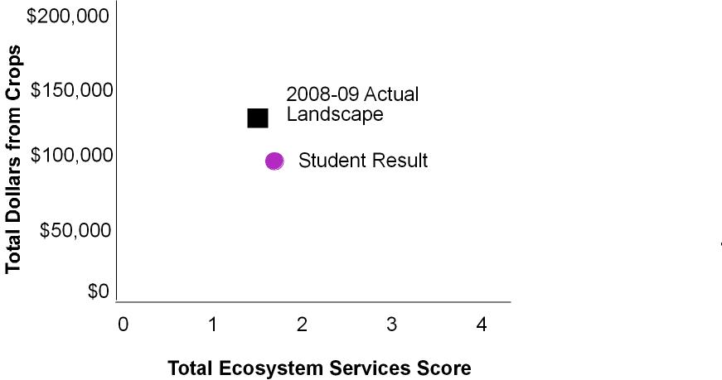

- Now graph the results for each student in the class.

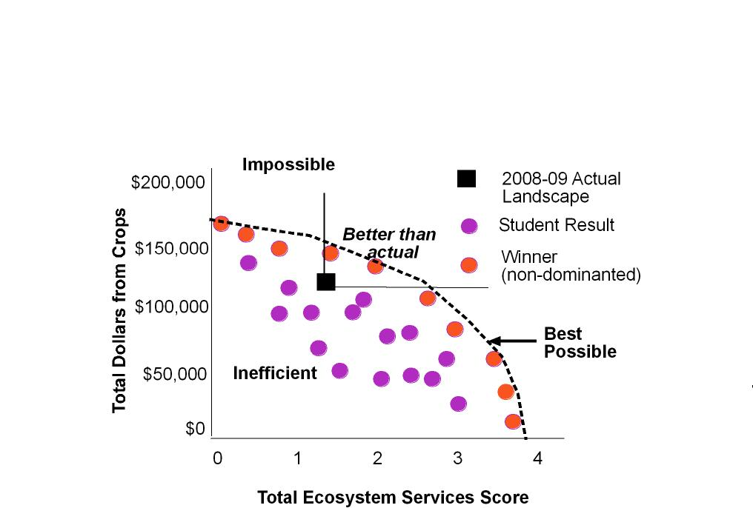

- Who wins? Anyone who did better than the actual landscape wins. Also anyone whose result is non-dominated wins. That means that no one else did better on both crop dollars and ecosystem services.
- The winning results (orange) form the production possibilities frontier, the best the watershed is capable of doing. The purple results could do better – so one else's land use pattern did better on both scores.
- Let the students try again and compare results.

